Political Polarization and Media: A Case Study of Turkey

Talha Oz

Computational Social Science, George Mason University

4400 University Drive, MSN 1J3, Fairfax, VA 22030

toz@gmu.edu

~~~ Please do not cite without permission, this is a draft copy ~~~

Abstract

Political media bias is an important problem in political communications literature. In this article, extending on the selective exposure theory by publicly available social media data, I first propose an audience similarity metric for news organizations. Then by adopting a network theoretical approach I provide a computational framework for inferring media groups at different granularities. Furthermore, a novel method for calculating media-party parallelism (MPP) using social media is introduced. To evaluate the robustness of the methods better, a country whose media system is known to have a high degree of polarized pluralism and political parallelism is chosen as a test case. For that matter, two kinds of observational datasets of Turkey is compiled using Twitter API: the first being the news audience dataset and the second one relating to the political audience. In particular, by collecting data before and after two major developments in Turkish politics, their effects to the media system are investigated. First, algorithmically identified media clusters at different scales help explain the diversity in researchers’ categorizations of the Turkish media organizations. Second, through MPP analysis I show that outlet preferences of Turkish parties are quite different from one another, and identified an inverse correlation between the ruling party and the main opposition party. Findings regarding MPP are not only verified by comparing the measurements before and after the major developments as a longitudinal study, but also validated by the results of cross-sectional surveys. Finally, interactive visualizations are created to facilitate the interpretation of the results and to highlight the findings.

# Introduction*[1]*

Media plays an important role in democracies by acting as a watchdog of the powerful, a gatekeeper for disseminating valuable information, a fact checker, and a civic forum reflecting cultural interests and trends. Yet, measuring its performance is not easy. In this study, extending on the well-established selective exposure theory (Sears and Freedman 1967) by publicly available social media data, I first propose an audience similarity metric for news organizations. Then by adopting a network theoretical approach I provide a computational framework for inferring i) relative positions of news organizations, and ii) media groups at different granularities. Furthermore, a novel method for calculating media-party parallelism (MPP) using social media is introduced. More specifically, contribution of this work is twofold:

* By constructing a network of audience similarity of Turkish media, i) their relative positions are visualized, and ii) the sub communities within the network are discovered by exploiting an entire set of their public Twitter subscribers
* Media-party parallelism is measured for Turkish media outlets and political parties before and after two major political developments in Turkey

To the best of my knowledge, this is the first study to use computational methods along with social media data to infer media groupings as well as media-party parallelism in a multi-party system.

## Twitter and Traditional News Agencies

Twitter is a popular microblog platform where its users form an interest network, i.e. someone who is interested in the *tweets* (microblog posts) of others can follow them without a reciprocal interest. In addition to its popularity and live coverage skills, this interest/follower relationship makes Twitter a great tool for outreach purposes. Therefore, traditional news media sources are early adapters of Twitter and their subscribers have been ever increasing[2]. How news organizations use Twitter, decide on what to tweet or how (Armstrong and Gao 2010; Thrall, Armstrong, and Oz 2015) is out of scope of this paper, but simply put, the common practice regarding the format of the tweets is that along with a story/article title they usually share an image and a link to the corresponding news webpage on their own website. In this study, based on the assumption that online subscribers of a particular news media also prefer that source over the others in its original format (be it a newspaper or a broadcast media) -in other words assuming that online and offline audience profile being similar- I am rather interested in who their subscribers are.

According to a recent survey (Pew Research Center 2015), 63% of the U.S. adults using Twitter consume news on Twitter, and about 73% of those do so by following news organizations. The case is not so different in Turkey, the 40 major Turkish news organizations included in this study have a total of 18.5 million subscriptions -by 6.2 million unique subscribers-, while the aggregate daily circulation rate of all the Turkish national newspapers is only around 4.5 million[3].

## Selective Exposure Theory and Twitter

The principle of selective exposure is one of the most widely accepted principles in sociology as well as social psychology (Sears and Freedman 1967). Based on the theory of cognitive dissonance (Festinger 1962), selective exposure posits that individuals favor news sources that agree with their pre-existing opinions. Selective exposure is also described as “any systematic bias in audience composition” (Sears and Freedman 1967).

In the words of Lazarsfeld et al., “exposure is always selective” (Lazarsfeld, Bernard, and Gaudet 1948), and in the case of Twitter, it is simply achieved by “following” an account[4]. An et al. visualized media bias through Twitter by looking at co-subscription relationships of major U.S. based news outlets and mapped them along one dimensional dichotomous political spectrum (An et al. 2012). They find a strong correlation between their results and the media bias scores calculated in the seminal work of Groseclose and Milyo (2005). I also adapt co-subscription approach in calculating similarities of media outlets. However unlike An et al., I use a symmetric similarity metric in calculating similarities of outlet pairs, and then position the outlets in a 2-D space. Furthermore, I also infer media groups by constructing a similarity network and detecting sub-communities within.

Golbeck and Hansen (2014) placed the major US media on 1-D conservative-liberal spectrum by computing the political preference of their Twitter followers. They only utilize some of their subscribers who also follow at least one Member of Congress (MC). Political preference score (p-score) of an outlet is then calculated by p-scores of its subscribers, which are derived from known scores[5] of the MCs they follow. This approach for computing political preference of media outlets is not applicable to multi-party systems because in such a setting we cannot score deputies (representatives) in a continuous scale as in the case of DW-Nominate or alike (Poole and Rosenthal 2000). Therefore, I plot the political preference distribution of an outlet’s audience over the parties, and also measure its effective number of parties (ENP) as discussed in the next section.

## Media-Party Parallelism

The term press-party parallelism was coined by Seymour-Ure, where he described the alignment concept mainly with three features: ownership, content, and partisanship of readers (Seymour-Ure 1974). If a tie exists between a media organization and a political party in any of these dimensions then it is feasible to talk about presence of parallelism. Though the original theory addressed the printed press only, due to the enrichment in broadcast -and web- media landscape over time, today it encompasses these as well.

Although there are many studies focusing on the organizational and content level analysis, readership dimension of the MPP received much less attention (Çarkoğlu and Yavuz 2010). This might be due to the challenging nature of the latter. Organizational level ties can be investigated by one person, media content might be encoded by several people, but surveying high number of readers appears to be the most costly one.

Using a survey[6] data conducted after 2002 and 2007 elections (Çarkoğlu and Kalaycıoğlu 2007), Çarkoğlu and Yavuz studied press-party parallelism for six major Turkish newspapers and also aggregated some others in two categories as sports and conservatives (Çarkoğlu and Yavuz 2010). Survey participants were asked the paper they read most frequently and also their voting intention. In the article, results are evaluated by a measure called the effective number of parties (ENP) (Laakso and Taagepera 1979). For comparability purposes, and considering widespread use of ENP in comparative politics studies, I also measure ENPs to show the readers’ party concentration distribution for particular media outlets.

# Turkish Media and Politics

Turkish media is a perfect example for Mediterranean or Polarized Pluralist model, as introduced and discussed in “Comparing Media Systems: Three Models of Media and Politics”, the seminal work of Hallin and Mancini in the field of international comparative media system research . Turkish newspaper circulation is low, political parallelism is high, professionalism is weak, media ownership is problematic, and there is a strong state intervention to the entire media system[7] (Yesil 2014; Kaya and Çakmur 2010; Ellis 2015; Kurban and Sözeri 2012; Turkey Task Force 2014; The Committee to Protect Journalists 2015; Corke et al. 2014; Nyman-Metcalf 2014; Bureau of Democracy, Human Rights and Labor 2015; Çarkoğlu and Yavuz 2010).

Hallin and Mancini categorize “pluralism” into two as external and internal pluralism. While the former is about the diversity of ideas among different organizations (i.e., inter-media), the latter is concerned with the plurality within an organization (i.e., intra-media).

## Groups of Turkish News Media

Categorizing Turkish news media by their political alignments is a daunting task. On empirical grounds, such a study needs to stand on content analysis, or other means of indirect measurements such as scoring the political affiliations of the journalists, measuring the partisanship of the audience, or examining the ownership structures and funding sources (Yesil 2014; Çarkoğlu and Yavuz 2010).

Kaya and Çakmur provide a historical background of the linkages between the media and politics in Turkey and assert that (by the late 2000s) the Turkish media is sharply divided into two camps as pro- and anti-government (Kaya and Çakmur 2010). On the other hand, a Freedom House Special Report of 2014 reviews the ideological profiles of most of the Turkish media as “well-known and clear-cut political allegiances” and names five (as *Kemalist*, *leftist*, *Islamist*, *associated with Gulen movement* and *mouthpieces for the government*), while still considering a group of the rest as “mainstream” (Corke et al. 2014). Acknowledging empirical and normative risks -of lack of data and a scrupulous methodology-, Yesil also categorizes major Turkish newspapers according to their political alignments: “AKP-friendly”, “highly-critical of the government” and “mainstream” (Yesil 2014). A report by Rethink Institute follows a more explicit taxonomy and clusters the Turkish media into five groups (loyal, public, pool, restrained and opposition media); although descriptions for each category is provided, it still lacks a clear methodology and empirical support of how each individual media outlet is classified (Turkey Task Force 2014).

To the best of my knowledge there is only a single study (Çarkoğlu, Baruh, and Yıldırım 2014) on grouping Turkish news media that stands on empirical grounds. Based on a face-to-face survey data[8] of 687 participants “reading” one of the 15 newspapers examined, 569 of them also expressed whom they would vote for -among the four parties in the parliament. Although the authors note that the survey is “nationally representative”; my main concern is about its sample size. A case supporting my concern also mentioned in a footnote that for a particular newspaper only 14 respondents indicated that they were reading it, and its factor score categorized it as *opposition*, whereas “addition of a few more AKP readers would have led the newspaper to be categorized as *mainstream*”. Following a factor analysis approach authors adopt one-dimensional AKP-CHP view of political alignment for newspapers and classify them as conservative, mainstream and opposition (Çarkoğlu, Baruh, and Yıldırım 2014).

Exploiting subscriber information of news organizations on Twitter, I first propose a readership similarity metric of news organizations. Then by adopting a network theoretic approach I provide a computational framework for clustering them. Finally, I compare these empirical findings with the subjective groupings of the publications mentioned. Details of the data, methodology and the findings are further discussed in the following chapters.

## Two Major Developments in Turkish Politics

Turkey witnessed two major political developments in last 1.5 years. One is the great election success of a pro-Kurdish party, and the other is the then Prime Minister Erdogan’s -ongoing- “witch hunt”. Among many other societal implications, both developments have changed the audience profile of Turkish news media as well.

For the first time in the history of Turkish Republic, a pro-Kurdish party managed to clear the 10% electoral threshold to enter the parliament (Ayoob 2015; Kubilay 2015; Kızılkaya 2015). Peoples’ Democratic Party (HDP) received 13% of the votes (a 7% increase from the last general election) in the general elections held on June 7, 2015 and is now represented by 80 deputies[9] in the Grand National Assembly of Turkey (TBMM). The increase in the popularity of the party is inevitably reflected to and transformed the political alignment of media audiences at some degree. The question we attempt to answer in this study is how can we see and measure this change cost-effectively for individual news organizations.

Reporters Without Borders (RWB) ranked Turkey #149 out of 180 countries in the 2015 World Press Freedom Index (Reporters Without Borders 2015) and among other chronic diseases, a single case is mentioned, which grabs attention: “Rocked by *major* *corruption allegations*, the government has done everything possible to rein in the influence of its new Public Enemy No. 1, the *Gülen Movement*, to the increasing detriment of the rule of law” [emphasis added]. The movement referred by the report was used as an exit strategy for the corruption scandal revealed in December 2013. Then Prime Minister Erdogan reframed the scandal as a plot to overthrow his government (Gurbuz 2014), and started a witch hunt (Dumanli 2015; Hürriyet Daily News 2015). To emphasize the severity of this crisis in Turkey, quoting from a Freedom House special report: “The police raids that revealed a corruption scandal on December 17, and the allegations of massive bid rigging and money laundering by people at the highest levels of the government, sparked a frantic crackdown by the ruling Justice and Development Party (AKP). More journalists have been fired for speaking out. Thousands of police officers and prosecutors have been fired or relocated across the country. Amendments to the Internet regulation law proposed by the government would make it possible for officials to block websites without court orders. The government is also threatening the separation of powers by putting the judiciary, including criminal investigations, under direct control of the Ministry of Justice. The crisis of democracy in Turkey is not a future problem—it is right here, right now” (Corke et al. 2014).

Due to these two huge developments in Turkey, I expect to see: i) a dramatic change in political preference of audience of Gulen Movement affiliated news outlets, ii) and for many non-AKP affiliated outlets, a salient increase of their HDP audience rate.

# Data

I first handpicked[10] thirty-seven major Turkish news media organizations and using Twitter REST API[11] collected IDs of everyone subscribed to them (i.e., all of their followers) on Twitter. The total subscription count is more than eighteen million and number of unique subscribers is greater than six million. Twitter screen names of news organizations and numbers of their followers are available in Figure 1.

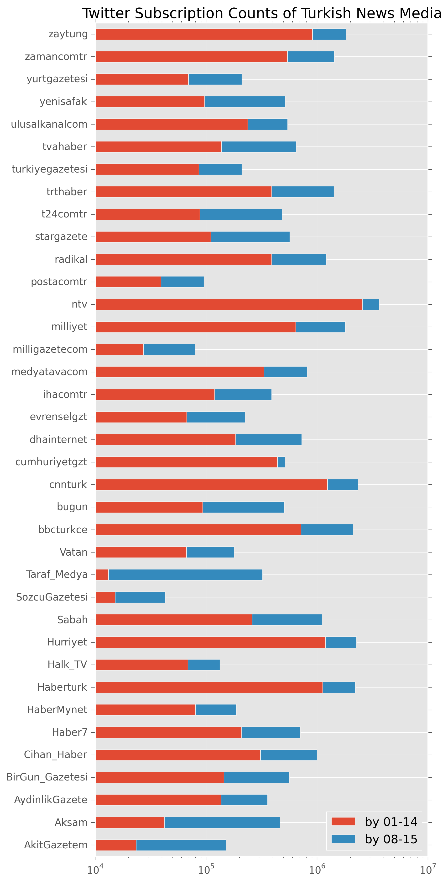 Similarly, I picked several popular Twitter accounts of each political party currently in the Turkish parliament and collected their follower IDs. Resulting numbers are given in Table 1 after filtering out accounts following more than one party.

Figure 1 Subscribers (follower counts) of Turkish news organizations on Twitter

|  |  |  |  |
| --- | --- | --- | --- |
| Party | Selected accounts | Size ‘13 | Size ‘15 |
| AKP | Akparti, AkTanitimMedya, AKKULIS* | 82.1K | 150K |
| CHP | CHP_online*, herkesicinCHP | 235K | 225K |
| MHP | MHP_Bilgi, Ulku_Ocaklari | 91.6K | 223K |
| BDP | BDPgenelmerkez*, HDP_Kongre*, HDPgenelmerkezi**, HDPonline** | 60.4K | 240K |

Table 1 Selected screen names and unique follower counts

# Methodology

Using co-subscription relationships of the news media, I first calculate a similarity value between each pair of news organizations, by combining the pairs, and then a weighted co-subscription network of Turkish news media is constructed. Finally, using a community detection algorithm on this network, I detect the clusters.

Pairwise similarities of news media are calculated based on their common followers. Since, number of followers of the media has high variance in our dataset, we choose meet/min coefficient (Goldberg and Roth 2003) as our similarity metric over more popular Jaccard index, i.e. . Let A and B be the set of follower IDs of two news media, then meet/min similarity of A to B is calculated by

Note that this metric is symmetric, and if A is a proper subset of B then their similarity is 1.

We calculate such pairwise similarities and observe values between 0.5% and 77% with a mean of 0.28. Distribution of similarities is shown in Figure 3. We also created a green-yellow-red heatmap to visualize these similarities (Figure 4).

Figure 2 Similarity distributions of news media pairs

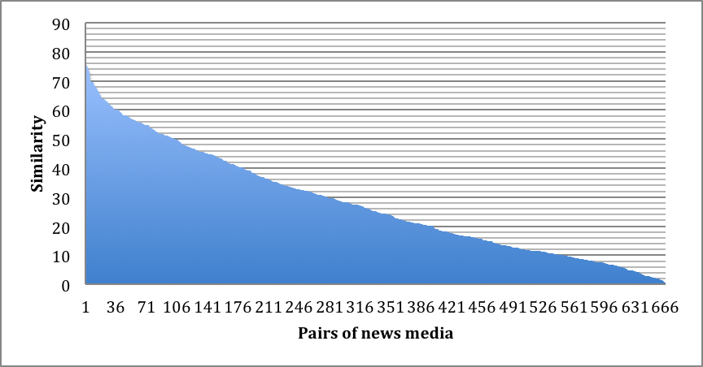

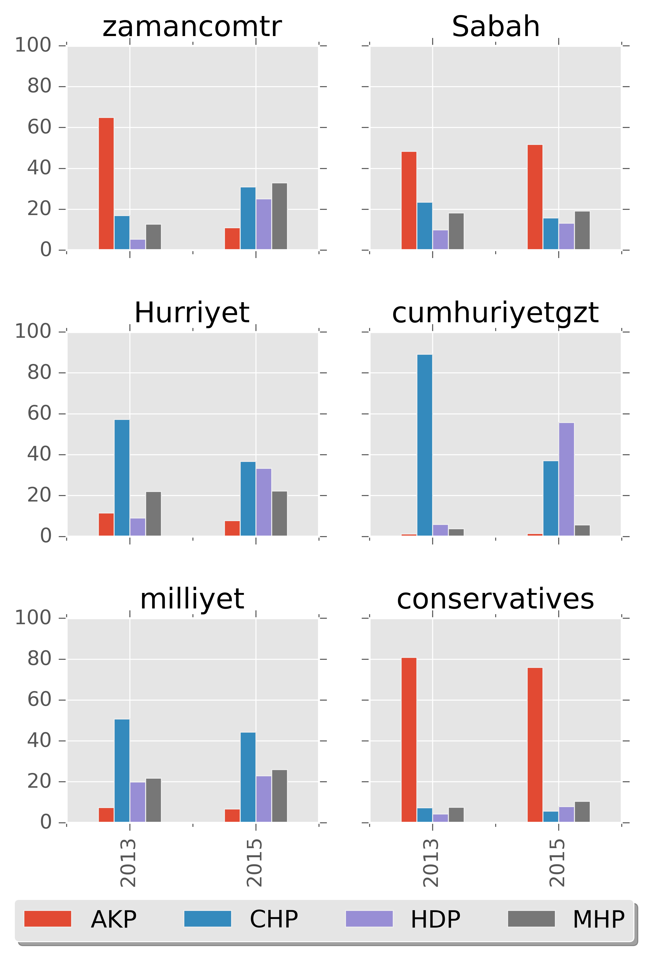

Figure 5 Subscribers of parties as well as newspapers

A weighted complete graph is generated where its vertices are the 37 news media and edge weights are the meet/min similarities of their endpoints. Then a modularity based method (Blondel et al. 2008) implemented in Gephi (Bastian, Heymann and Jacomy 2009) with different granularities is employed to detect the clusters in this generated graph. In networks, quality of a partition is usually defined by modularity, which for weighted graphs is defined as

where is edge weight, is node strength and is the total edge weight in the network. In simple English, modularity quality is defined as

To understand media groupings better, we investigated it at various resolutions with different number of partitions. (Lambiotte, Delvenne and Barahona 2009) achieve this by defining continuous-time stability of a partition by adding a random walker into the equation where its probability to be in the same community after a time can be tuned as a resolution parameter.

**Political Alignments.** For each party, I collect follower IDs from Twitter accounts listed in Table 1, and IDs following more than one party are filtered out. Distribution of party preference of each media audience is then calculated. For six major organizations, see Figure 5.

Findings are also presented using interactive charts where users can sort the media list by their descriptiveness for each party [12].

Finally, for each media effective number of parties (ENPs) is calculated with ENP=[(1/∑ (pi2))] where pi is the share of party *i* for the media.

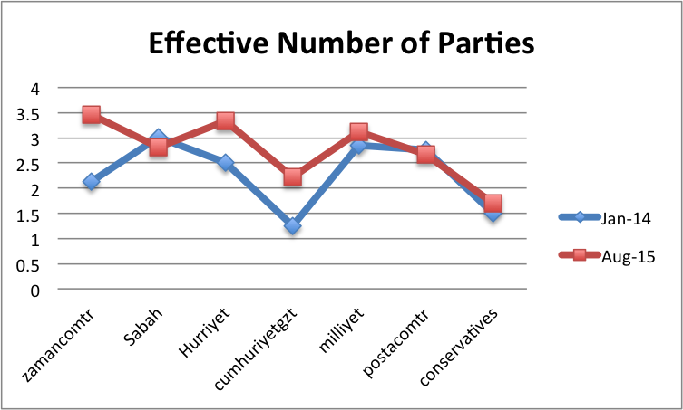

Figure 7 Higher ENP denotes more plural audience

**Visualizations**. News organization audience similarity network is visualized in Gephi by running Force Atlas 2 layout with lin-log mode to make clusters tighter (Noack 2007). Edge weights are proportionally drawn and those with less than %30 similarity are filtered out (not drawn). Figure 4 is an example where nodes and edges are colored by their partitions. An edge is grey if it is connecting nodes in two different communities.

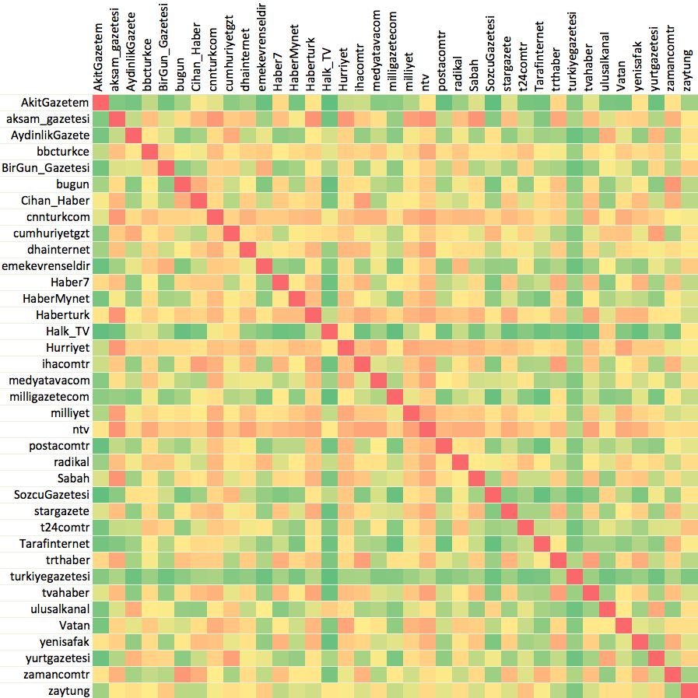

Figure 3 Heatmap of Turkish News Media

Multidimensional scaling (MDS) represents the objects geometrically whose pairwise (dis)similarity measures are given. Positions of the newspapers in Figure 6 are obtained by SMACOF (Scaling by majorizing a convex function) algorithm for metric MDS introduced by (De Leeuw and Heiser 1980) and implemented in Python’s scikit-learn module (Pedregosa et al. 2011).

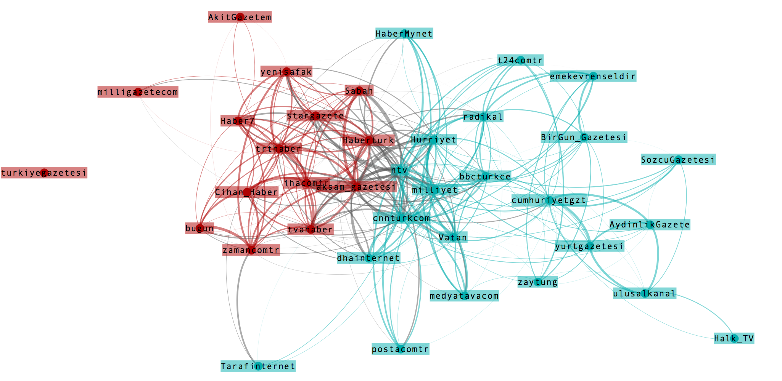

Figure 4 Turkish media clustered into two

Eleven clusters and pairwise similarities are visualized as an interactive adjacency matrix on my website[13]. Hovering or tapping on a slice gives percentage of party followers reading (i.e., also following) that media or group. Clicking on a media on the legend removes its share from the pie and redistributes shares of the remaining media.

# Discussion of Results

**Groups of news media**. Following a network theoretic approach Twitter follower similarity information can be used to detect the news media groups effectively. Beyond revealing media in the same ideological camps such as “loyals” (yenisafak, Haber7, AkitGazetem), I was also even able to detect the organizations owned by the same person as in the case of Dogan group (posta, hurriyet, milliyet)[14].

**Media-Party Parallelism**. ENP scores (Figure 7) suggest that Zaman, a Gulen Movement affiliated newspaper, has become much more plural after the “witch hunt”. Again for Zaman, unlike the other five plots in Figure 5, AKP’s share drops to ~10% from 64% in a very short period of time. One interesting result is the unexpected high increase of HDP share for Cumhuriyet. This might be explained by curious CHP supporters who do not follow their own party but follow HDP as it has become much more sympathetic recently.

# References

An, Jisun, Meeyoung Cha, Krishna Gummadi, Jon Crowcroft, and Daniele Quercia. 2012. “Visualizing Media Bias through Twitter.” In *Sixth International AAAI Conference on Weblogs and Social Media*. http://www.aaai.org/ocs/index.php/ICWSM/ICWSM12/paper/view/4775.

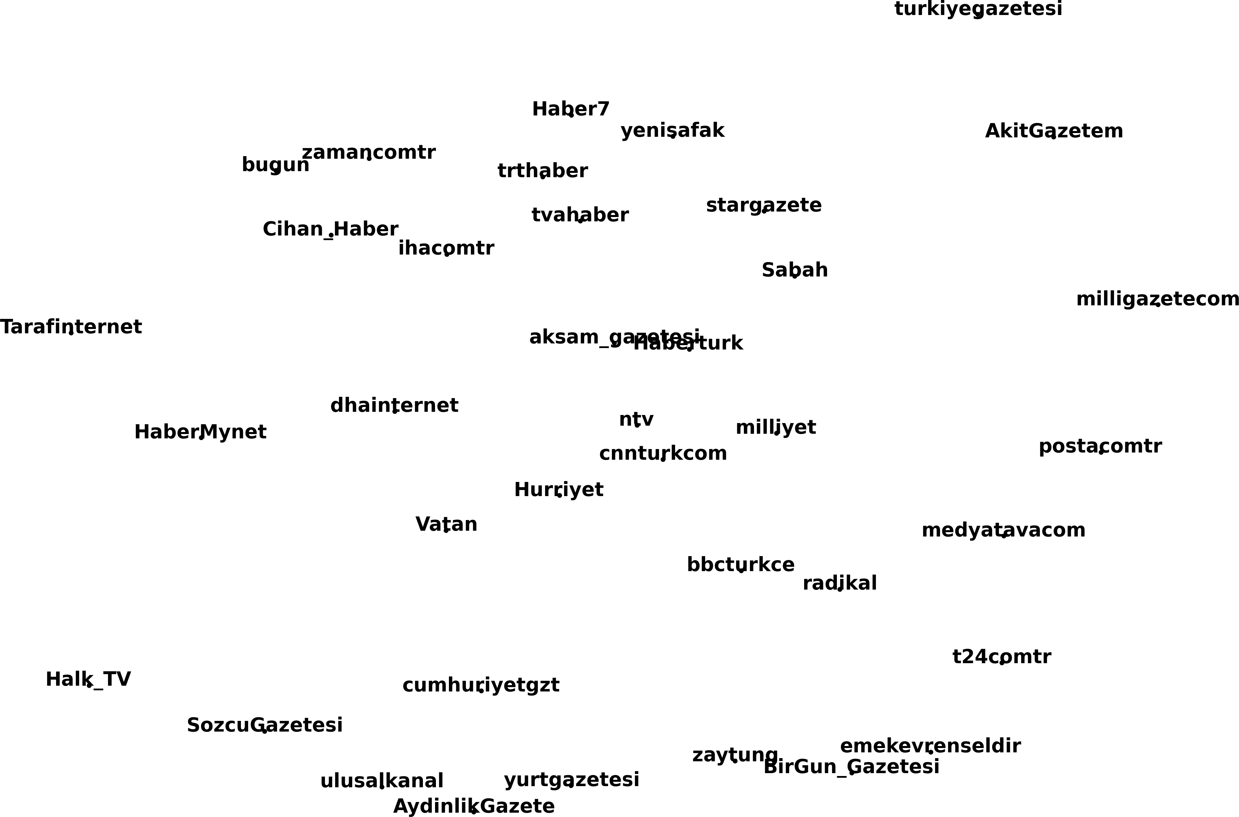

Figure 6 News organizations plotted in 2D by MDS

Armstrong, Cory L., and Fangfang Gao. 2010. “Now Tweet This How News Organizations Use Twitter.” *Electronic News* 4 (4): 218–35. doi:10.1177/1931243110389457.

Ayoob, Mohammed. 2015. “The Kurds in Command.” *Project Syndicate*. June 10. http://www.project-syndicate.org/commentary/kurdish-hdp-party-turkish-elections-by-mohammed-ayoob-2015-06.

Bureau of Democracy, Human Rights and Labor. 2015. “Turkey 2014 Human Rights Report.” Country Reports on Human Rights Practices for 2014. U.S. Department of State. Accessed July 22. http://www.state.gov/j/drl/rls/hrrpt/humanrightsreport/index.htm.

Çarkoğlu, Ali, Lemi Baruh, and Kerem Yıldırım. 2014. “Press-Party Parallelism and Polarization of News Media during an Election Campaign The Case of the 2011 Turkish Elections.” *The International Journal of Press/Politics* 19 (3): 295–317. doi:10.1177/1940161214528994.

Çarkoğlu, Ali, and Ersin Kalaycıoğlu. 2007. *Turkish Democracy Today: Elections, Participation and Stability in an Islamic Society*. London: IB Tauris.

Çarkoğlu, Ali, and Gözde Yavuz. 2010. “Press–party Parallelism in Turkey: An Individual Level Interpretation.” *Turkish Studies* 11 (4): 613–24. doi:10.1080/14683849.2010.540116.

Corke, Susan, Andrew Finkel, David J Kramer, Carla Anne Robbins, and Nate Schenkkan. 2014. “Democracy in Crisis: Corruption, Media, and Power in Turkey.” *A Freedom House Special Report*, March.

Dumanli, Ekrem. 2015. “Ekrem Dumanli: Turkey’s Witch Hunt against the Media.” *The Washington Post*, January 1. https://www.washingtonpost.com/opinions/ekrem-dumanli-turkeys-witch-hunt-against-the-media/2015/01/01/7544429a-8fad-11e4-ba53-a477d66580ed_story.html.

Ellis, Steven M. 2015. “Democracy at Risk - IPI SPECIAL REPORT ON TURKEY.” *International Press Institute (IPI)*, IPI SPECIAL REPORT ON TURKEY, , March.

Festinger, Leon. 1962. *A Theory of Cognitive Dissonance*. Vol. 2. Stanford university press. https://books.google.com/books?hl=en&lr=&id=voeQ-8CASacC&oi=fnd&pg=PA1&dq=Festinger,+1962.+&ots=9x69SvndAD&sig=ZYAjhPzQZVnfiJAKMewhBbOpNaE.

Golbeck, Jennifer, and Derek Hansen. 2014. “A Method for Computing Political Preference among Twitter Followers.” *Social Networks*, Special Issue on Political Networks, 36 (January): 177–84. doi:10.1016/j.socnet.2013.07.004.

Groseclose, Tim, and Jeffrey Milyo. 2005. “A Measure of Media Bias.” *The Quarterly Journal of Economics*, 1191–1237.

Gurbuz, Mustafa. 2014. *The Long Winter: Turkish Politics After the Corruption Scandal*. Rethink Institute.

Hürriyet Daily News. 2015. “POLITICS - Turkish PM Erdoğan Vows ‘to Sterilize’ Gülen Movement ‘by Boiling or Molecularizing.’” Accessed July 24. http://www.hurriyetdailynews.com/turkish-pm-erdogan-vows-to-sterilize-gulen-movement-by-boiling-or-molecularizing.aspx?PageID=238&NID=66327&NewsCatID=338.

Kaya, Raşit, and Barış Çakmur. 2010. “Politics and the Mass Media in Turkey.” *Turkish Studies* 11 (4): 521–37. doi:10.1080/14683849.2010.540112.

Kızılkaya, Emre. 2015. “5 Surprising Results of Turkey’s Election.” Accessed July 24. http://www.hurriyetdailynews.com/5-surprising-results-of-turkeys-election.aspx?pageID=517&nID=83669&NewsCatID=550.

Kubilay, Arin. 2015. “Turkey and the Kurds -- From War to Reconciliation?” *eScholarship*, March. http://escholarship.org/uc/item/3229m63b.

Kurban, Dilek, and Ceren Sözeri. 2012. “Does Media Policy Promote Media Freedom and Independence? The Case of Turkey.” *Turkish Economic and Social Studies Foundation*, Media Studies Series - 3, Democratization Program (Caught in the Wheels of Power: The Political, Legal and Economic Constraints on Independent Media and Freedom of the Press in Turkey). http://www.tesev.org.tr/Upload/Publication/6e7010fe-0f80-4c8d-821f-5278f2ca14ee/12301ENGmedya3WEB09_07_12.pdf.

Laakso, Markku, and Rein Taagepera. 1979. “Effective Number of Parties: A Measure with Application to West Europe.” *Comparative Political Studies* 12 (1): 3–27.

Lazarsfeld, Paul F., R. Berelson Bernard, and Hazel Gaudet. 1948. *The People’s Choice*. New York: Columbia University Press.

Nyman-Metcalf, Katrin. 2014. “Freedom of Expression in Turkey.” http://www.ombudsman.gov.tr/en/contents/files/pdf/Katrin%20Nyman-Metcalf.pdf.

Pew Research Center. 2015. “The Evolving Role of News on Twitter and Facebook.” Pew Research Center. Accessed July 20. http://www.journalism.org/2015/07/14/the-evolving-role-of-news-on-twitter-and-facebook/.

Poole, Keith T., and Howard Rosenthal. 2000. *Congress: A Political-Economic History of Roll Call Voting*. Oxford University Press. https://books.google.com/books?hl=en&lr=&id=x9vyGly7hLcC&oi=fnd&pg=PA3&dq=Congress:+A+Political%E2%80%93Economic+History+of+Roll+Call+Voting&ots=mZ5FESVn6h&sig=I78Zk6UQFdO8MdjYB1358go06eM.

Reporters Without Borders. 2015. “2015 World Press Freedom Index.” Accessed July 22. http://index.rsf.org.

Sears, David O., and Jonathan L. Freedman. 1967. “Selective Exposure to Information: A Critical Review.” *The Public Opinion Quarterly* 31 (2): 194–213.

Seymour-Ure, Colin. 1974. *The Political Impact of Mass Media*. Vol. 4. London: Constable; Beverly Hills, Calif: Sage Publications.

The Committee to Protect Journalists. 2015. “CPJ Calls on Turkish Government to Reverse Anti-Press Measures - Committee to Protect Journalists,” February 9. https://cpj.org/2015/02/cpj-calls-on-turkish-government-to-reverse-anti-pr.php.

Thrall, Trevor, Andrew Armstrong, and Talha Oz. 2015. “Circle of Doom? How the Public Shapes the Public Sphere.” In *APSA 2015*.

Turkey Task Force. 2014. “Diminishing Press Freedom in Turkey.” *Rethink Institute* Rethink Paper 18 (November). http://www.rethinkinstitute.org/diminishing-press-freedom-turkey-2/.

Yesil, Bilge. 2014. “Press Censorship in Turkey: Networks of State Power, Commercial Pressures, and Self-Censorship: Press Censorship in Turkey.” *Communication, Culture & Critique* 7 (2): 154–73. doi:10.1111/cccr.12049.

Mitchell, Rosenstiel and Christian, *The State of the News Media 2012*. At <http://stateofthemedia.org/print-chapter/?print_id=11554>

Kurban and Sozeri 2012. Caught in the Wheels of Power: The Political, Legal and Economic Constraints on Independent Media and Freedom of the Press in Turkey. *Turkish Economic and Social Studies Foundation. Democratization Program. Media studies series – 3*

Conover, Goncalves, Ratkiewicz, Flammini, Menczer 2011. Predicting the Political Alignment of Twitter Users. Privacy, Security, Risk and Trust (PASSAT), IEEE Third International Conference on Social Computing (SocialCom)

An, Quercia and Crowcroft 2013. Fragmented Social Media: A Look into Selective Exposure to Political News. *Proceedings of the 22nd international conference on World Wide Web companion,* 51-52

Zamal, Liu and Ruths 2012. Proceedings of the Sixth International AAAI Conference on Weblogs and Social Media

Blondel 2008. Fast unfolding of communities in large networks. *Physics and Society (physics.soc-ph) J. Stat. Mech. (2008)* P10008

Bastian, Heymann and Jacomy 2009. Gephi: An Open Source Software for Exploring and Manipulating Networks. *International AAAI Conference on Weblogs and Social Media*

Bastian, Heymann and Jacomy 2009. Laplacian Dynamics and Multiscale Modular Structure in Networks

Goldberg and Roth 2003. Assessing experimentally derived interactions in a small world. *PNAS 2003,* 100, 4372–4376

De Leeuw and Heiser 1980. Multidimensional scaling with restrictions on the configuration. *Multivariate analysis 5*, 501-522

1. Copyright © 2015, Association for the Advancement of Artificial Intelligence (www.aaai.org). All rights reserved.
2. As of July 2015, CNN has 18.5M, the New York Times has 18.1M, and BBC Breaking News has 16.8M subscribers (followers) on Twitter
3. <http://www.medyatava.com/tiraj>, accessed on July 2015.
4. I use the term “subscribing” interchangeably.
5. Either of ADA or DW-Nominate scores can be used as they both map MCs to a continuous range that represents 1-D left-right spectrum.
6. I could not find survey sample size information in Carkoglu’s 2010 paper. I share my concern about it in the groups of Turkish News Media section.
7. Including bans on access to Twitter and YouTube.
8. I could not found any media related survey question in the reference given in the original article. Rather, another article of the same author mentions the question –for his 2002 and 2007 surveys- as “Which newspaper do you read most frequently?” (Çarkoğlu and Yavuz 2010)
9. Of 550 seats:

   <https://www.tbmm.gov.tr/develop/owa/milletvekillerimiz_sd.dagilim>
10. Accounts were initially obtained from a list published on the web on December 2013, few missing others added into the 2015 dataset. http://www.twitterunluleri.com/haber/
11. To facilitate data collection process for other projects and researchers I created a web application <http://dd-css.com> that allows its users to download IDs of followers of any public account on Twitter.
12. Available at

    www.mli.gmu.edu/toz/readership/groups/descriptiveness.html
13. http://www.mli.gmu.edu/toz/readership/
14. Dogan group indeed sold Milliyet in 2011 (was in the group since 1979). Since its style has not been changed since then, handover is not noticeable. Due to space limitations, clusters at different scales are made available at [www.mli.gmu.edu/toz/readership](http://www.mli.gmu.edu/toz/readership)